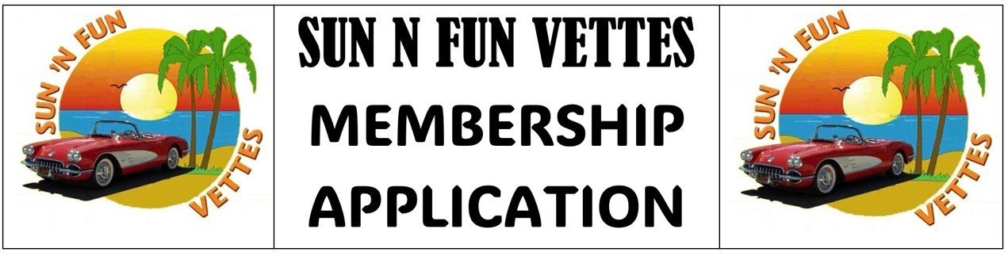

NAME: ________________________________ __________________________________________
First Name Last Name
HOME ADDRESS: _________________________________________________________________
CITY: ______________________________________ STATE: ________ ZIP CODE: ____________
HOME PHONE (or n/a): ______________________ CELL PHONE ___________________________
EMAIL ADDRESS: __________________________________________________________________
BIRTH DATE: ________ /_________ ANNIVERSARY DATE: _______ /_____/_______
MONTH DAY MONTH DAY YEAR SPOUSE: OR OTHER: ____________________________ ________________________________
First Name Last Name
CELL PHONE___________________________ BIRTH DATE: _________ /___________
MONTH DAY
EMAIL ADDRESS: _________________________________________________________________
-----------------------------------------------CORVETTES PRESENTLY OWNED -------------------------------------------
Body Style Body Style
Year (Coupe or Convertible) Color Year (Coupe or Convertible) Color
______ ___________________ _______ ______ ___________________ _______
______ ___________________ _______ ______ ___________________ _______
______ ___________________ _______ ______ ___________________ _______
I hereby apply for membership in The Sun ‘n Fun Vettes Club and agree to abide by its By-Laws.
BY EXECUTION OF THIS APPLICATION, I RELEASE AND DISCHARGE SUN ‘N FUN VETTES, INC. AND ALL OTHERS CONNECTED WITH THE MANAGEMENT OF THIS CLUB FROM ANY AND ALL KNOWN/UNKNOWN INJURIES, LOSSES, JUDGEMENTS, AND/OR CLAIMS FROM ANY MEMBER TO HIS PERSON OR PROPERTY.

Date: ____________ Signature of Applicant: ______________________________________________
Annual Dues: Family or Single: $30.00. Renewable each January.
Bring completed form to a meeting or event, or mail to:
Sun ‘n Fun Vettes
PO Box 272311
Tampa, FL 33688-2311

